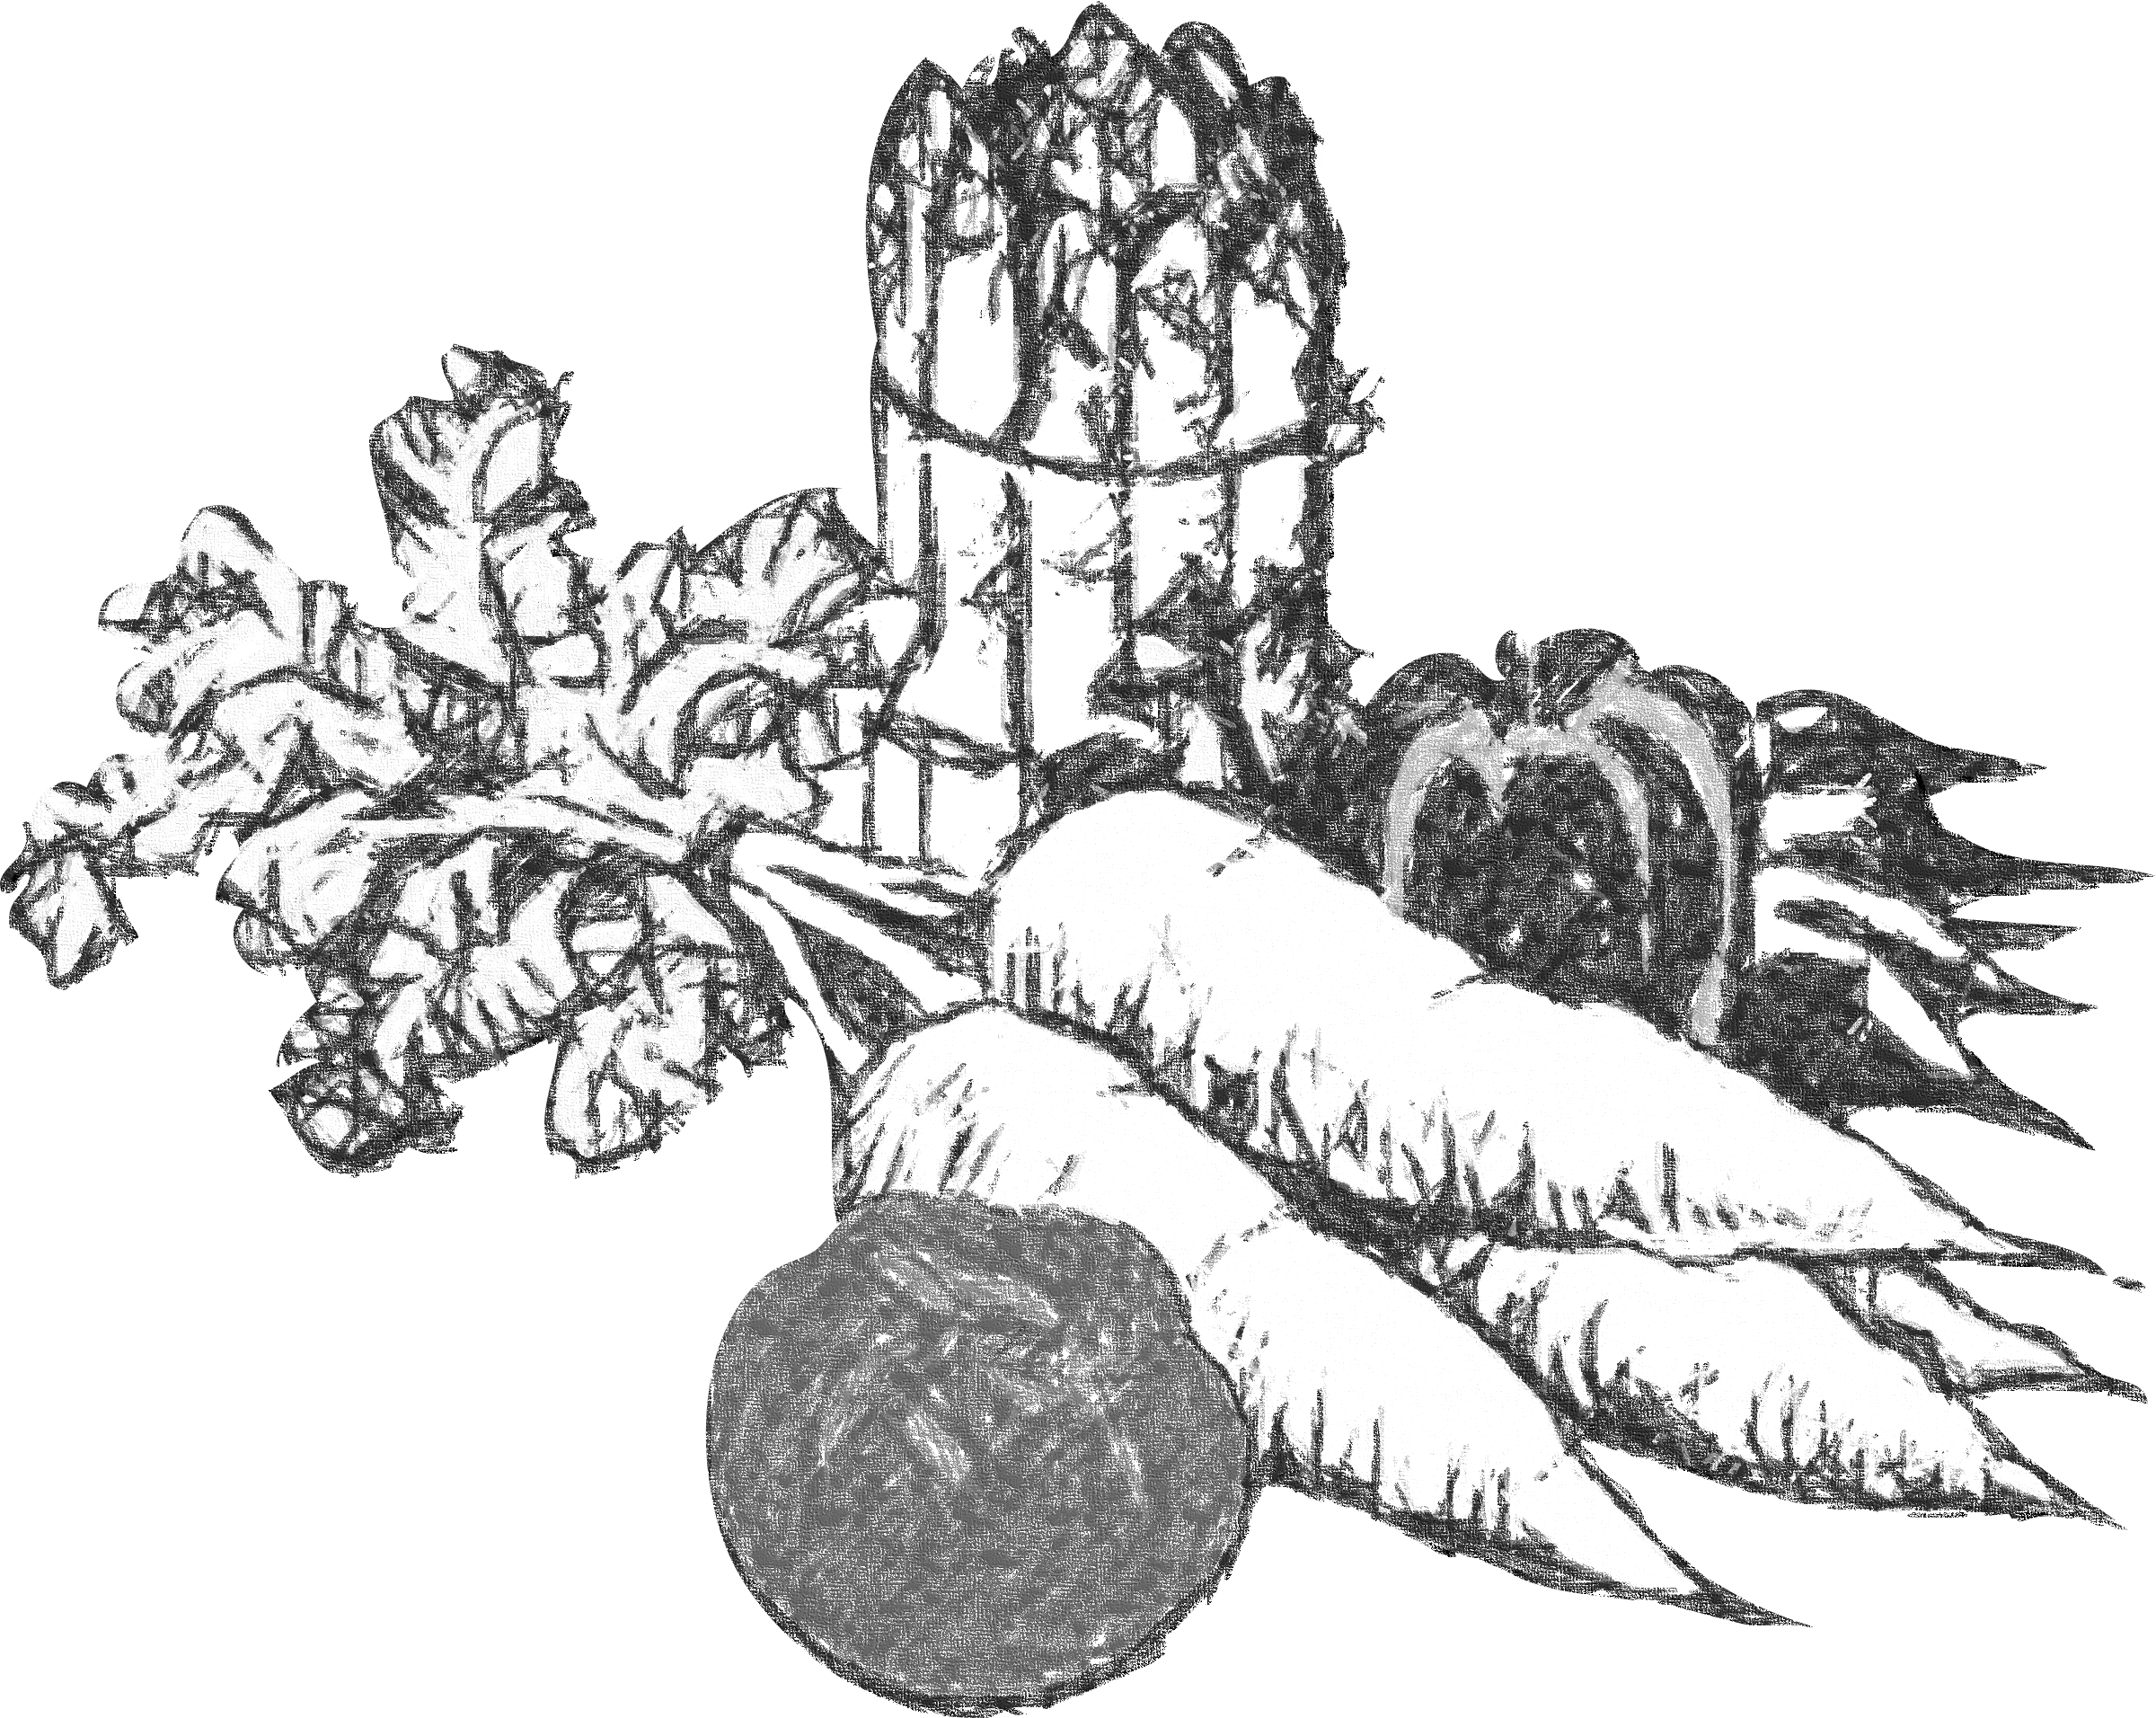
PANDY SHOW
&
EAST WALES AND BORDERS
VINTAGE ENTHUSIASTS
VINTAGE RALLY
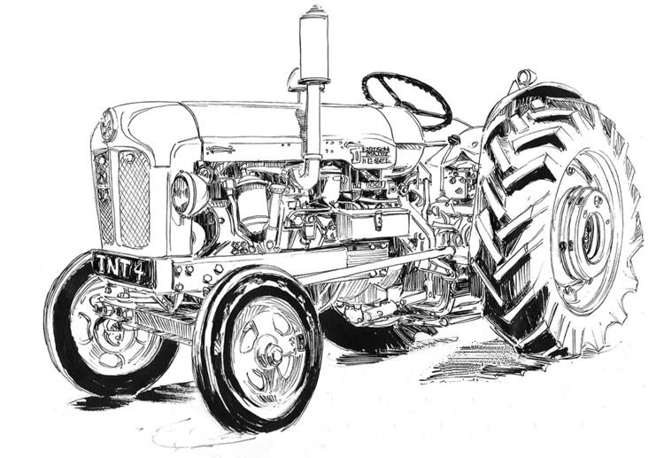
SUNDAY, 23rd JUNE, 2024.

Sunday 23rd June 2024

PRODUCE SCHEDULE

TIME TO GET KNITTING, SEWING,
CRAFTING AND GARDENING.
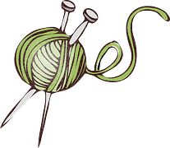
BE READY FOR OUR 2024 SHOW
PRODUCE TENT
ALL EXHIBITORS SHOULD REPORT TO THE PRODUCE TENT SECRETARY ON ARRIVAL.

PRODUCE AND CRAFT EXHIBITION RULES
Entry for all Adult Sections 50p. Children are Free.
Prizes: - 1st. £2.00, 2nd. £1.50, 3rd. £1.00
1. All exhibitors must stage their entries before 11.00am and must not remove them before 4.00pm.
School classes by 10.00am please.
2. The Produce Tent will close at 11.00am for judging.
We will endeavor to reopen the Tent at 12.30pm.
3. The Judge's decision is final.
4. Points towards Cups and Shields will be awarded as follows:
1st- 3 pts, 2nd- 2 pts, 3rd- 1 pt.
5. Competitors may enter up to 3 exhibits in any class but will only receive the prize-money and points for their highest placed entry.
6. Any items not removed by 4.30pm will be auctioned and any monies raised along with any Prize-money not collected by 5.00pm on the day of the show will be donated to charity.
7. The organizers will not be responsible for any accident,
loss or damage that may occur.
SECTION 1.
FRUIT AND VEGETABLE CLASSES.
1. Collection of Vegetables - 4 different kinds.
2. 3 Potatoes - any variety.
3. 5 Pods of Broad Beans.
4. 5 Pods of Early Peas.
5. 2 Courgettes.
6. 3 Beetroot.
7. 7 Shallots.
8. 2 Lettuce.
9. 2 Cucumbers.
10. 5 Radish.
11. Selection of a Salad Items.
12. 5 named Culinary Herbs.
13. 5 Sticks of Rhubarb.
14. A Dish of Soft Fruit.
15. A Single Vegetable noted for its looks.
SECTION 2.
FLORAL ART AND FLOWER CLASSES.
16. Petite arrangement-not exceeding 9"x9".
17. An arrangement for a dinner party - to include candles and recycled material. Not to exceed 18"x18".
18. An arrangement in an item of kitchen equipment.
19. An arrangement from the hedgerow. Not to exceed
18"x18".
20. Container of Pansies and/or Violas.
21. Vase of Roses - 5 stems.
22. Vase of Pinks and/or Carnations.
23. Vase of Sweet Peas -9 spikes.
24. Vase of Lupins - 3 spikes.
25. Vase of Garden Flowers.
26. Best Flowering Pot Plant.
27. A Specimen Cactus.
28. Most Unusual Flower.

FUN SECTION
29. Longest Daisy Chain.
30. Biggest Dock Leaf.
31. Tallest Thistle.

SECTION 3.
COOKERY CLASSES.
32. Victoria Sponge.
33. Afternoon tea fruit cake.
34. 5 Welsh cakes.
35. Fruit tart.
36. Carrot Cake.
37. 5 Fruit Scones.
38. A Savory Quiche.
39. A Jar of Homemade Jam.
40. A Jar of Homemade Savory Preserve.
41. 6 Eggs.

SECTION 4.
HANDICRAFT CLASSES.
42. Congratulations Card - made from recycled material.
For Example: Wedding, Birth, New House etc.
43. A Knitted Garment.
44. Animal Portrait, any medium.
45. A Knee Blanket, 1m square, any medium.
46a. A Winter Hat.
46b. A Shopping Bag from material scraps.
47. A Door Stop from recycled wood or metal.
48. Photography
Subject: A Recycled Container used in the Garden.
SECTION 5.
CHILDREN'S CLASSES.
Pre School
49. Make a Vase from a Recycled Pot and Decorate.
50. A Green Waste Monster from Vegetables.
51. Decorate a Digestive Biscuit - Recycle Logo.
Reception - Year 2
52. A Miniature Garden.
53. Make an Instrument from Recycled Material.
54. Baking - 6 Jam Tarts.
Year 3 - Year 6
55. Design a Recycle Logo - Any Medium.
56. Make a Puppet from Recycled Material.
57. Decorate 3 Cup Cakes.
Year 7 - Year 11
58. Design a Recycling Bin.
59. Make a Pillow/Cushion/Pillowcase from Recycled Material.
60. Bake a Cake and Decorate with Recycling Theme.

